Phase 1 Source Group 1
UMGC CMSC 495 Section 6384
Arora, Neil
Pierce, Holden
Stigall, Michael
Thompson, Kosie

Introduction
This document details the implementation of a classic Breakout-style arcade game. Phase 1 focuses on establishing a stable, playable foundation by implementing core gameplay mechanics within a modular and maintainable architecture. The primary objectives are to deliver a functional game loop, essential entity behaviors, and a structured codebase that supports testing and future expansion.

1 Project Setup

1.1 Environment Configuration
Development was conducted using Visual Studio Code as the primary Integrated Development Environment (IDE), configured with Python extensions for enhanced productivity. The PyGame library was installed via pip to handle infrastructure and framework. The PyTest library was installed via pip to support efficient, thorough testing. All required packages and their specific versions are documented in the ReadMe.md file to ensure consistent environment setup across different machines.

1.2 Version Control
A Git repository was initialized at the project's inception to track all source code, assets, and documentation. A branch system is intended to be used if the complexity of the project requires it. Each member has agreed to commit to their own personal branch before merging to main if and only if all group members deem it necessary for that particular push. The .gitignore file is configured to exclude Python cache directories, IDE-specific settings, and temporary files, keeping the repository clean and focused on source artifacts.

Project Organization
The project adheres to a clear, hierarchical directory structure that separates source code, assets, tests, and configuration. The root directory contains the ReadMe.md and some configuration files, as well as the main entry point script, breakout.py. The \Assets\ directory stores level definition files in JSON format and any graphical sprites or fonts that cannot be handled by pygame. The \Tests\ directory houses all unit test modules. The \Objects\ directory contains constructors and frameworks for all game objects such as the ball and paddle. The \Managers\ directory handles all the audio and other runtime management scripts. There is a \UI\ folder to handle UI implementations, and finally there is our \Core\ directory that contains important scripts like __init__, config.py, and gameState.py.

2 Core Functionality
This section describes the core functional elements of the Breakout game implementation during Phase 1 of the project. Phase 1 focuses on establishing a stable and playable foundation of the Breakout-style game by implementing essential gameplay mechanics, algorithms, and modular components. The goal of this phase is to deliver a functional game phase of the MVP demonstrating a playable game, maintainable structure and extensibility to build on for future phases.

2.1 Implementation Features
Phase 1 implementation is focused on foundational gameplay mechanics and systems required for a playable experience. The paddle movement allows the player to control a horizontal paddle using keyboard input. Movement is smooth and frame-rate independent, ensuring consistent play experience.
Ball movement is implemented using a two-dimensional velocity vector updated each frame based on elapsed time. The ball responds to collisions with the paddle, bricks, and screen boundaries through deterministic reflection logic. When the ball falls below the bottom void boundary, a life is deducted and the ball is reset to the starting position.
Block collision functionality supports a basic block type that is destroyed upon a single collision with the ball. When a block is destroyed, the scoring system is updated. The HUD provides a scoring counter and indicator with the player’s remaining lives during game play. Game state transitions, including a new game and triggering the Game Over state when all lives are lost are not implemented as part of the immediate game play loop. State changes will be implemented to allow for game over, start game, and menu states within the next phase.
A dedicated Level class is implemented to manage level structure and progression. The Level class is responsible for loading block layouts, which are provided in JSON. The Level class will instantiate blocks, track remaining blocks, and determine when a level has been completed. Abstracting in this way allows level definitions to be modified or extended independently of core gameplay logic. For Phase 1, only a single playable level is implemented.
Combined, these features establish a complete and playable core which will serve as the baseline game for future enhancements. During the next phase the team will be adding state transitions, further modularizing the code, and including menus which will enable the addition of options and configuration modifications.

2.2 Choice of Algorithms
The algorithms selected for Phase 1 prioritize simplicity, determinism, and clarity to support both gameplay consistency and maintainability. Paddle movement is calculated using linear translation based upon player input and a configurable speed value and clamped to the horizontal bounds of the screen.
Ball movement is handled using basic vector arithmetic, where position updates are computed as a function of velocity and delta time. Collision detection uses axis-aligned bounding box (AABB) comparisons to determine intersections between the ball and other game objects such as blocks and the paddle. Collision response is implemented by inverting the appropriate component of the velocity vector depending on the collision surface.
Block management within a level is supported by a simple collection-based algorithm. The Level class maintains a collection of active blocks and updates the collection as blocks are destroyed. Level completion is determined by checking whether all destructible blocks have been destroyed, triggering either level completion logic or game termination depending on the current scope.
Scoring and life management use simple counter-based algorithms. Block destruction triggers immediate score updates, while life loss events decrement a life counter and reset the ball state. These algorithms are computationally lightweight and well suited to a real-time 2D arcade game.
Use of the chosen algorithms reflects the team’s desire to create a faithful reconstruction of the classic Breakout arcade game. Each algorithm is similar, if not the same, as the original game and ensures the game will behave as the user expects it should.

2.3 Modular Components
The Phase 1 implementation follows a modular design to encourage simplicity and promote code reuse. Core gameplay entities are encapsulated within individual classes, including Palle, Ball, Block and Level. Each class is responsible for managing its own state, update logic, and rendering behavior.
The Level class serves as a structural coordinator rather than a rendering or physics engine. It encapsulates level specific data such as block layout and type. Interfaces are provided for updating and querying current level state.
Game flow is managed by a central game loop which coordinates input handling, state updates, collision checks, and rendering. Game states such as active gameplay and Game Over are represented by distinct logical components, during Phase 2 clean transitions will be enabled by moving and expanding upon the state code within the manger system.
Supporting systems, such as scoring and life tracking, are implemented within the core game loop and during Phase 2 will be moved into their own managers to avoid tight coupling with gameplay entities. Configuration values, including movement speeds, screen dimensions, and initial lives, are centralized to simplify tuning and maintenance.
This modular architecture improves readability, facilitates debugging, and provides a flexible foundation to simplify future phases of development.

3 Documentation / Implementation of Code
This section describes the documentation practices and implementation standards used throughout Phase 1 of the project. Our team prioritized readability, consistency, and maintainability to ensure that all contributors could easily understand and extend the codebase. Each module follows a clear organizational structure, and classes are designed to encapsulate individual gameplay responsibilities.
Inline comments are used to clarify non-obvious logic, particularly within collision handling, movement updates, and level loading. Method names and variable names were selected to be descriptive and consistent across modules. Configuration values such as screen dimensions, movement speeds, and default object sizes are centralized in the Core configuration files, reducing duplication and simplifying future tuning.
External documentation is provided through the project’s ReadMe.md file, which outlines installation steps, required dependencies, and instructions for running both the game and automated unit tests. This ensures that new contributors can quickly configure their development environment and verify functionality.
The implementation emphasizes modular design by separating gameplay entities (Ball, Paddle, Block, Level) from supporting systems such as input handling, collision management, and scoring. This structure improves maintainability and enables incremental development in later phases.

3.1 Example of Comments
Code comments are used to explain key logic and document intended behavior. For example, within the Block class, comments describe the purpose of each method and clarify how damage is applied to blocks during gameplay. Similar documentation exists within the Ball and Paddle classes to explain movement calculations and collision boundaries.
Concise inline comments accompany critical sections such as collision detection, velocity updates, and level loading, ensuring that future contributors can quickly understand how each subsystem operates.
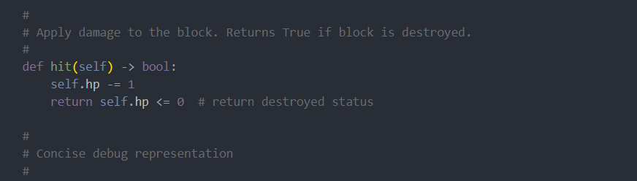
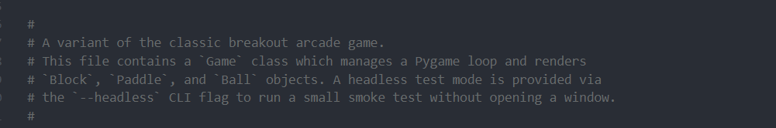

3.2 Example of Smoke Tests
We performed basic smoke testing by launching the game and verifying that essential gameplay mechanics functioned correctly. Functions such as the following: paddle movement, ball physics, block collisions, score updates, and life loss behavior. These manual checks confirm that the application starts successfully and that the primary gameplay loop operates as expected.
In addition to manual smoke testing, automated unit tests were introduced early in development to validate core object behavior independently of the full game loop. This includes tests for Block initialization, hit logic, and bounding rectangle generation. These tests help detect regressions quickly and provide confidence that core gameplay components remain stable as development continues.

4 Unit Testing
Unit testing was used to confirm that the main game modules work correctly on their own before running the full game. We created automated tests for the core gameplay objects (Ball, Paddle, Block, and Level loading) and verified expected behavior using assertions. All unit tests are stored in the tests/ folder and can be run together to quickly confirm everything still works after changes.

4.1 Major Functionality to Test
The unit tests focus on the main gameplay behaviors that are most important to the Breakout game.
Ball (direction, movement, hitbox)
- Confirms the ball correctly scales the direction values (vx, vy) into a consistent direction.
- Confirms the ball does not get stuck when initialized with no direction (vx=0, vy=0).
- Confirms update(dt) moves the ball the correct distance over time.
- Confirms rect() returns the correct collision box around the ball.
Paddle (movement, boundaries, hitbox)
- Confirms paddle movement updates x correctly when moving left/right.
- Confirms the paddle cannot move off-screen (clamps at the left and right edges).
- Confirms rect() returns the correct collision box around the paddle.
Block (init, hit logic, hitbox)
- Confirms blocks initialize with correct position/size and settings (hp, score, color, etc.).
- Confirms rect() returns the correct collision box.
- Confirms hit() reduces HP correctly and reports when the block is destroyed.
Level (map loading, validation, conversion)
- Confirms Level.from_file() loads a JSON level file correctly (width, height, tile size, and blocks).
- Confirms invalid level data is handled correctly (ex: negative grid coordinates, invalid JSON, missing file).
- Confirms all level JSON files in the levels/asset’s directory can be loaded and converted into valid Block objects.

4.2 Unit Testing Framework
Our project uses pytest as the unit testing framework. Pytest was chosen because it runs all tests quickly in one command and gives clear pass/fail results, which makes it easy to verify the code after changes.
All unit tests are stored in the tests/ folder and follow pytest’s naming rules:
- Test files start with test_ (ex: test_ball.py, test_paddle.py, etc.)
- Test functions start with test_
Using the command:
python -m pytest -q tests
The results showed 21 tests passed successfully, confirming the tested modules (Ball, Paddle, Block, and Level loading) are working as expected.

Figure 1. Running the full unit test with pytest.
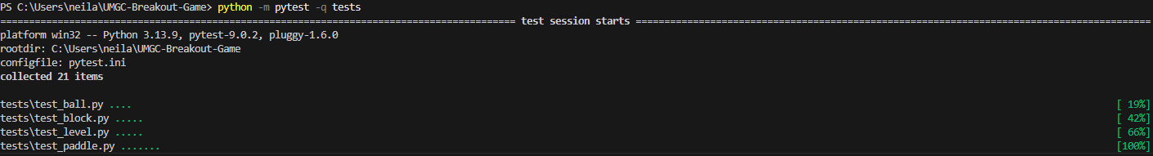

Figure 2. Pytest results showing all 21 tests passed.

5 Conclusion
In Phase 1, we established a functional foundation for our Breakout-style arcade game by implementing core gameplay mechanics within a modular architecture. Our team delivered essential systems including paddle control, ball movement, block interaction, scoring, and level loading, resulting in a playable minimum viable product.
Our codebase emphasizes scalability through clear separation of gameplay entities, managers, and configuration components. We implemented automated unit testing using pytest to validate Ball, Paddle, Block, and Level loading behavior, with all tests passing successfully. This confirmed the stability of our foundational systems.
Throughout this phase, we applied best practices such as version control, documentation, modular design, and automated testing to support effective collaboration and maintain code quality.
In Phase 2, we will expand our implementation with game state transitions, menu systems, enhanced UI elements, additional levels, and further modularization. With a stable and tested baseline in place, we are well positioned to continue development and deliver a more complete game experience.

